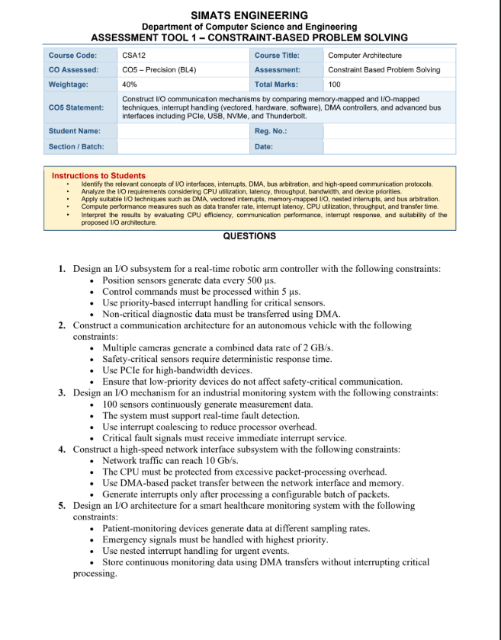
K SANDHIYA
(192521378)
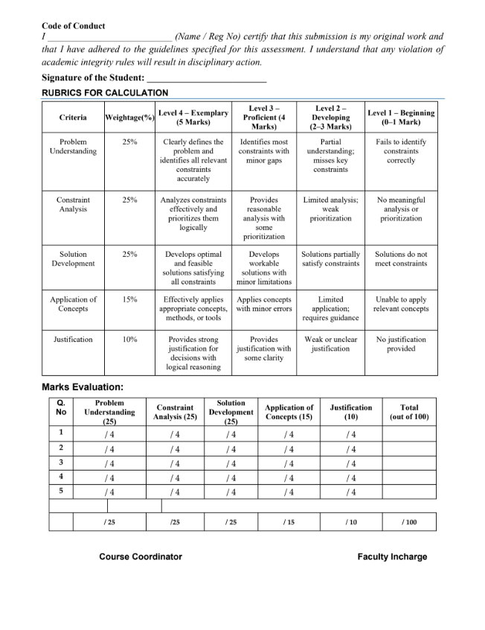

1. I/O Subsystem for a Real-Time Robotic Arm Controller
Requirements: Position sensors produce data every 500 μs (2 kHz), while control commands must be processed within 5 μs.
Proposed architecture
Position Sensors
│
▼
Sensor Interface ──► Priority Interrupt Controller
│ │
│ High-priority ISR
│ ▼
│ Real-Time Controller
│ │
│ Motor Actuators
│
└──────────────► DMA Buffer
│
▼
Diagnostic Memory
Operation
- Position sensors are connected to a dedicated sensor interface.
- Each critical sensor generates a high-priority interrupt when new data arrives.
- The interrupt controller uses priority-based interrupt handling, ensuring critical sensor interrupts preempt lower-priority activities.
- The ISR should be extremely short: capture the sensor value, timestamp it, and place it in a real-time buffer.
- Control commands are processed through the highest-priority real-time task/ISR so that the 5 μs deadline is met.
- Non-critical diagnostic information is transferred through DMA, avoiding CPU involvement for every data item.
- Double buffering or ring buffers can prevent data loss while the CPU processes one buffer and DMA fills another.
Result: Critical sensor/control operations receive deterministic CPU service, while DMA handles background diagnostic I/O efficiently.
2. Communication Architecture for an Autonomous Vehicle
The cameras generate a combined 2 GB/s, equivalent to approximately 16 Gb/s, so a high-bandwidth interconnect is required.
Proposed architecture
Cameras
┌────┬────┬────┐
▼ ▼ ▼ ▼
Camera Interfaces
│
▼
PCIe Switch
│
┌──────┴──────┐
▼ ▼
High-Speed GPU Main Memory
│ │
└──────┬──────┘
▼
Perception System

Safety Sensors ──► Real-Time Bus/MCU
│
▼
Priority Interrupt Controller
│
▼
Safety Controller ──► Actuators

Low-Priority Devices ──► Separate/Lower-Priority I/O Path
Design
- High-bandwidth cameras connect through PCIe, using multiple PCIe lanes as required by the aggregate bandwidth.
- Camera data is transferred directly into memory/GPU memory using DMA, minimizing CPU copying.
- Safety-critical sensors use a dedicated deterministic communication path, such as a real-time bus or dedicated MCU.
- Safety interrupts receive the highest priority.
- PCIe traffic from cameras and other high-volume devices is isolated from safety-critical traffic using separate controllers, queues, or PCIe resources.
- Low-priority devices use lower-priority queues and cannot monopolize CPU or bus resources.
- Buffering and flow control prevent camera bursts from delaying safety messages.
Result: Camera data receives high-throughput PCIe communication, while safety-critical sensor communication remains deterministic and isolated from low-priority traffic.
3. I/O Mechanism for an Industrial Monitoring System
There are 100 continuously operating sensors, so generating one CPU interrupt for every measurement could create excessive processor overhead.
Proposed architecture
100 Sensors
│
▼
Sensor Interface / I/O Controller
│
├──────────────► Critical Fault Detector
│ │
│ Immediate Interrupt
│ ▼
│ CPU/ISR
│
▼
Sensor FIFO / Buffer
│
▼
Interrupt Coalescing
│
▼
CPU
Operation
- Sensor measurements are first collected by an I/O controller or FIFO.
- Interrupt coalescing is used for normal sensor data.
- For example, the controller may interrupt the CPU after a specified number of measurements or after a specified timeout.
- The CPU then processes multiple sensor readings during one interrupt instead of servicing 100 separate interrupts.
- A critical fault signal bypasses interrupt coalescing.
- Fault signals immediately generate a high-priority interrupt.
- The fault ISR identifies the affected sensor and initiates the required protective action.
- Ring buffers/FIFOs ensure that measurements are not lost between interrupt events.
Result: Normal measurements cause fewer CPU interrupts, while critical faults receive immediate service.
4. High-Speed Network Interface Subsystem
The network may reach 10 Gb/s, so processing every packet through a CPU interrupt would create significant overhead.
Proposed architecture
10-Gb/s Network
│
▼
┌──────────────┐
│ Network NIC │
└──────┬───────┘
│
│ DMA
▼
┌──────────────┐
│ Ring Buffers │
│ in Memory │
└──────┬───────┘
│
▼
Packet Processing
│
▼
Interrupt after
configurable batch
Design
- Use a 10-Gb/s network interface card (NIC) with DMA support.
- Incoming packets are transferred directly from the NIC into preallocated memory buffers.
- The CPU does not need to copy every packet from the NIC.
- Descriptor-based ring buffers are used for efficient packet management.
- Instead of generating an interrupt for every packet, the NIC generates an interrupt after a configurable batch, for example:
  - every N packets, or
  - after a specified timeout.
- Interrupt moderation should be configurable so the system can trade latency against CPU overhead.
- Multiple receive queues can be assigned to different CPU cores to support parallel processing.
- For extremely high traffic, hardware packet filtering can discard irrelevant packets before they reach the CPU.
Result: DMA and interrupt batching significantly reduce CPU overhead while maintaining high throughput at 10 Gb/s.
5. I/O Architecture for a Smart Healthcare Monitoring System
Different patient-monitoring devices produce data at different rates, while emergency signals require immediate attention.
Proposed architecture
Patient Devices
┌────────┬────────┬────────┬───────────┐
│ ECG │ SpO₂ │ Temp. │ Emergency │
│ High │ Medium │ Low │ Signal │
└───┬────┴───┬────┴───┬────┴─────┬─────┘
│ │ │ │
▼ ▼ ▼ ▼
DMA DMA DMA Highest-Priority
Channels Channels Channel Interrupt
│ │ │ │
└────────┴────────┴─────┐ ▼
│ Emergency ISR
▼
Main Memory
│
▼
Monitoring System
Design
- Each monitoring device is assigned an appropriate I/O channel according to its sampling rate.
- Continuous monitoring data is transferred using DMA, allowing devices to write directly into memory without requiring an interrupt for every sample.
- Circular/ring buffers can be used for continuous ECG, temperature, oxygen saturation, and other measurements.
- Emergency devices generate highest-priority interrupts.
- A nested interrupt controller allows an emergency interrupt to preempt a lower-priority monitoring operation.
- The emergency ISR should immediately perform essential actions such as recording the event, notifying the control system, or activating an alarm.
- Normal DMA transfers continue in the background without unnecessarily interrupting critical processing.
- DMA buffers should be protected from overwriting unread data.
Result: Continuous patient data is efficiently stored using DMA, while emergency events receive immediate, highest-priority CPU attention.
Summary
System | Main I/O Technique | Critical Requirement
Robotic arm | Priority interrupts + DMA | Control response within 5 μs
Autonomous vehicle | PCIe + DMA + isolated safety path | 2 GB/s camera data without affecting safety
Industrial monitoring | Interrupt coalescing + immediate fault interrupts | 100 sensors with fast fault detection
10-Gb/s network | DMA + packet batching | Reduce CPU packet-processing overhead
Healthcare monitoring | DMA + nested interrupts | Emergency signals get highest priority
Overall, the designs use interrupts for time-critical events and DMA for high-volume/non-critical data, which minimizes CPU overhead while maintaining deterministic response where required.

